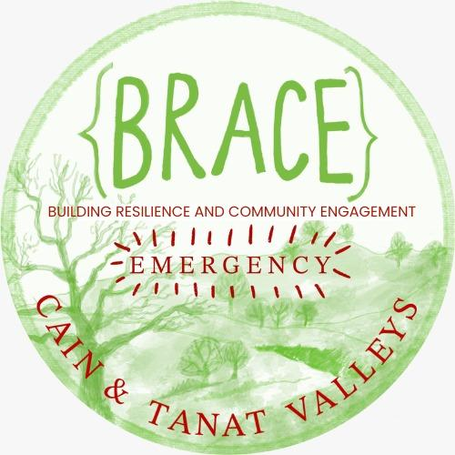
Job Description

Job title: Project Coordinator
Reports to: Diana (BRACE Treasurer) and Femke (BRACE Committee Member)
Location: Homeworking, with travel around the Cain and Tanat Valley
Contract: Freelance, 8 hours per week for c.90 weeks
Rate: £15 - £20 per hour (depending on experience)
Start date: ideally within one month.

About us:

We, BRACE (Building Resilience And Community Engagement), connect people in Cain and Tanat Valleys to strengthen our ability to respond to crisis. We bring the community together to learn, support one another, and take positive, practical action.

Through active projects like: our Community Garden, Cae Bodfach forest garden, Repair Café, Library of Things, Y Pantri (Community Fridge) we help build everyday resilience and community engagement within our local community, whilst also reducing waste and our impact on the planet.

To find out more, please head to our website at https://www.brace.wales/, or follow us on Facebook here: https://www.facebook.com/share/g/1CSUAM3d2r/.

In January 2026, we received substantial funding from The National Lottery (Awards for All fund) to recruit a Project Coordinator. The responsibilities below outline the scope of the role, but the Project Coordinator won’t be expected to deliver this work alone. They’ll work closely as part of a supportive team with our seven Committee Members, drawing on their combined experience and receiving day-to-day guidance and help whenever needed.

Job purpose:

As the Project Coordinator, you will bring our community together, encourage new members to join, build more social connections to make us more resilient in the face of the multiple crises we face at worldwide and community levels. The Project Coordinator will have a physical presence in our community, at a variety of events, public meetings, workshops, volunteering sessions, social occasions and more.

Key Responsibilities
Working closely with BRACE’s volunteer Steering Committee, you’ll help turn ideas into practical action and keep projects moving over this two-year period. You’ll be a friendly, visible point of contact for members, volunteers and local partners, supporting day-to-day coordination as well as longer-term growth.
You will:
- Grow and strengthen existing projects (supporting regular volunteers with projects, in particular, work-days and training in the Community Garden and Cae Bodfach forest garden).
- Help new projects get off the ground (e.g. clothing swaps, a community energy group), from early planning through to launch.
- Support the planning and delivery of events and talks, including stalls and community events (e.g. St Myllin’s Day stall, Great Big Green Week, Mini Fest) and speakers/visits for regular in-person Open Meetings.
- Coordinate skill-sharing workshops by linking up local experts with what the community wants to learn.
- Build relationships and collaborate with local organisations and neighbouring communities, including through memberships such as Repair Café Wales, Benthyg Cymru and Social Farms & Gardens.
- Act as a hub for communications and feedback, helping gather, organise and share information, stories and simple data that supports learning and reporting.
- Create and maintain easy-to-use marketing resources that members and volunteers can use for community engagement.
- Promote BRACE activities using social media and other appropriate channels.
- Encourage more people to join BRACE as free members and help them feel welcomed and informed.
- Support volunteers to produce BRACE’s newsletter and social media content, helping with planning, drafting and scheduling.
- Be a visible presence in the community by running more Open Meetings, attending local events, and coordinating and/or delivering presentations to other groups.
- Organise a ready-to-go event stall set-up (materials, signage, information, and a simple checklist) so BRACE can show up consistently and confidently.
- Keep the Steering Committee updated with regular activity updates and maintain an active connection with BRACE members.
- Spot and suggest improvements—proactively looking for ways BRACE can work more efficiently and effectively.

Person specification
We’re looking for someone who enjoys connecting people, keeping things organised, and making community activity happen. You don’t need to tick every box as BRACE Committee members, and the wider network will be very willing to support and guide where needed. We’re interested in transferable skills and a willingness to learn.
Skills and experience (essential)
- Experience coordinating, organising or facilitating projects (this could be from paid work, volunteering, community groups or lived experience).
- Ability to plan ahead and think strategically, while also enjoying practical delivery.
- Confident and comfortable being out and about in the community and building rapport with a wide range of people, including volunteers.
- Strong written and verbal communication skills (e.g. regularly updating the Committee, promoting events, writing clear updates for social media channels, speaking to local groups).
- Excellent organisation and project coordination skills, with good attention to detail and the ability to juggle multiple tasks and deadlines.
- Comfortable with everyday IT (e.g. Email, Google Drive, Excel) and willing to use simple systems to keep track of contacts, activity and engagement.
- A working understanding of budgets (e.g. tracking spend, keeping simple records, supporting cost-effective decisions).
Skills and experience (desirable)
- Some experience using social media and basic marketing tools; confidence using creative tools such as Canva is a plus.
- Experience gathering and using basic feedback or data (e.g. attendance, sign-ups, short surveys, stories/case studies).
- Experience recruiting, organising or motivating volunteers, including coordinating volunteers for events or work-days.
- Knowledge of the Welsh language would be beneficial.
Values and motivation (crucial)
- A genuine interest in BRACE’s mission and a strong alignment with BRACE’s values. We are committed to creating an inclusive and supportive environment where everyone can thrive and contribute to our mission.
- A collaborative, can-do approach, happy to pitch in with a varied workload, including occasional tasks outside the “core” list when needed.

Our organisational aims:

- To promote education within the local community of Llanfyllin and surrounding villages about the climate and ecological emergency.
- To understand and communicate the Welsh Well Being of Future Generations Act, Paris Accord etc.
- To promote community development by encouraging cooperation and mutual support in a changing physical and economic environment.
- To manage activities that promote community cohesion, increase food security & biodiversity, and to offer sustainable and environmentally responsible alternatives for the benefit of all.
- To be considerate and understanding of those who may have different opinions but ultimately members must accept there is a climate and ecological emergency and that we all need to work together to find solutions.
- To provide resources and support for projects and groups operating under the BRACE umbrella.

How to apply

We welcome all candidates to apply, regardless of age, sex/gender, disability, race, religion, sexual orientation, marital status or pregnancy/maternity. If you have any disability and require reasonable adjustment/s to any part of the process, then please contact BRACE Committee at brace.committee@gmail.com.

To apply, please put together a tailored CV + 1 page (max.) Covering Letter. In your Covering Letter, we would love to hear more about your motivation to apply and some examples of how you meet the criteria under the Person Specification.

If you have any questions before applying, please reach out to Femke or Diana at brace.committee@gmail.com.

To apply, please send your application to brace.committee@gmail.com by 9am on Monday 16th February, with the subject line ‘Project Coordinator Application’. We look forward to hearing from you.

Interviews will be held during the week commencing 23rd February and 2nd March.

